

Sponsored by

**Empire Chevrolet & Buick**

Wilkesboro, NC 28697

www. empirechevy.com



****

Monthly Newsletter of Foothills Corvette Club June/July 2017 Vol. 19 No. 6

[www.foothillscorvetteclub.net](http://www.foothillscorvetteclub.net)

[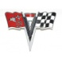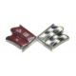](http://www.ecklers.com/)[Corvette Emblem, Front, Sunburst, 1973-1974](http://www.ecklers.com/corvette-emblem-front-sunburst-1973-1974.html)[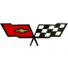](http://www.ecklers.com/corvette-front-emblem-crossed-flags-1982.html)Corvette Bumper Emblem, Front, 2005-2009®

*Chevrolet, Corvette,* and the Corvette emblems are registered trademarks of General Motors, Inc.

Foothills Crossed Flags, the monthly newsletter of Foothills Corvette Club, is emailed after the business meeting each month. Material must be in before the fifth of each month to Susie Miller 1778 Memorial Park Dr. Sparta, NC 28675 336-372-5292 or [susie.mrsmiller@gmail.com](mailto:susie.mrsmiller@gmail.com)

Business meetings are held the Second Tuesday of each month 6:00PM at Brushy Mountain Smokehouse and Creamery in North Wilkesboro unless changes are announced in this newsletter.

Rides or social events take place each month except in cases of inclement weather.

-------------------------------------------------

2016 Officers:

President Vince Catalano 704-483-4732

V Pres Larry Price 704-585-6762

Secretary Claudette Icenhour 828-632-9767

Treasurer Priscilla Norris 828-264-2376

Web Page: [www.foothillscorvetteclub.net](http://www.foothillscorvetteclub.net)

**Website: www.foothillscorvetteclub.net**

**Business Meeting: Tuesday June 13, 2017 6:00 at Brushy Mountain Smokehouse and Creamery - next meeting July 11, 2017. Our August meeting will be the 8th.**

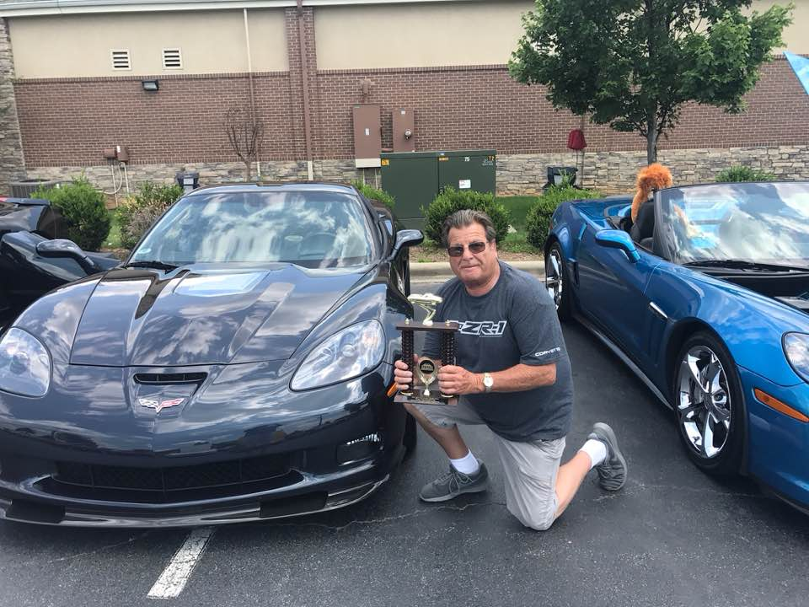

Vince’s ZR1 received the Ladies Choice Award on June 10th

**Our ride for August 12th will be to the Transportation Museum in Spencer. The cost will be $4.50 per person please let me know if you will be attending and have not signed up at a meeting. Mike needs to let them know the number attending the museum and for dinner arrangements. Mike will collect the money ($4.50) per person at the August meeting. If you are not able to attend that meeting you may give it to him the day of the ride. We will leave from Earnhardt Chevrolet in Newton at 2:00PM.**

**Please Collect Sponsorships for our All GM Cruise-In that will be held on September 30. A sponsor for our t-shirts is still $50. We are also collecting door prizes, too. If you know someone who will donate an item or gift card please collect it for our events this year.**

**We have two wonderful items for our raffle ticket this year; 1) Henry Golden Boy Rifle .22LR and 2) a custom made diamond pendant with our logo for the club from Michael’s Jewelry. If each member sells 25 tickets we will have all 2,000 tickets sold and our donations for local charities will be great for the end of the year.**

**Rachel Reavis has the tickets if you need some let her know.**

**Club Shirts**

**Order your new club shirt - Sharon Church, owns Embroidery By Design. She has moved from 10th St. in North Wilkesboro. She** **is now located in the same building as the Honda-Yamaha-Kawasaki motorcycle shop on US 421 West near the pool supply store.  Her address is: 4613A West Highway 421   Wilkesboro, NC 28697**

**- phone 336-667-8775. Give her a call before you go to make sure she will be there. Information will soon be on our website [www.foothillscorvetteclub.net](http://www.foothillscorvetteclub.net) If you do not have a club shirt consider ordering one.**

**Are You Ready for A Cruise- In?**

**Downtown Lenoir, NC Cruise-In the first Sat. of each month beginning April through Oct. 1st 4:00-9:00**t

**Hot Nights Hot Cars Cruise-In Pilot Mountain, NC - June 3, July 1, Aug. 5, Sept. 2, &**

**Oct. 7 3:00-9:30**

**Remember These… MC900370114[1]**

**Rachel & Bill Reavis**

**Libby Richey**

**Vince Catalano**

**Tony Guppone**

**Max Barlow**

**Ray Lovette**

**Attalissa Carrigan**

 

**Birthdays**

|  |  |  |  |
| --- | --- | --- | --- |
| June | Vince | Catalano | 4 |
|  | Beverly | Angell | 4 |
|  | Arthur | Pipek | 10 |
|  | Sam | Watkins | 15 |
|  | Jimmie | Holyfield | 25 |
|  |  |  |  |
|  |  |  |  |
| July | Sherry | Allen | 9 |
|  | Margie | Hines | 10 |
|  | Larry | Price | 15 |
|  | Calvin | Wyatt | 18 |
|  |  |  |  |



**Anniversaries**

|  |  |  |  |  |  |
| --- | --- | --- | --- | --- | --- |
| **JUNE** | Matthew | & | Libby | Richey | 11 |
|  | Tom | & | Susie | Miller | 15 |
|  | Ben | & | Margie | Hines | 15 |
|  | Jimmy | & | Miriam | Pittman | 20 |
|  | Bobby | & | Robyn | Wolgemuth | 22 |
|  | Vince | & | Jan | Catalano | 29 |
|  | Dick | & | Beverly | Angell | 30 |
|  |  |  |  |  |  |
|  |  |  |  |  |  |
| **JULY** | Ray | & | Betty | Lovette | 1 |
|  |  |  |  |  |  |

**The following is from one of the charities we donated to in 2016:**

Hi Susie,

The Foothills Corvette Club donated funds to High Country First In Families last year. Because of your donation we were able to assist 9  individuals with Developmental Disabilities with various item and services they needed.  If you would like a list of how the funding was spent, we would be happy to send one to your group. We are grateful for the donation and would love for you to continue your support to our program. I have attached a copy of our donation letter,  if you need any additional information please just let me know. If your group decides to assist again this year, please make checks payable to High Country First In Families.

Thanks,

Penny Souther, Chapter Direct

**Please mark your calendar with the events for the year **

**Join All the Corvette Events for 2017**

**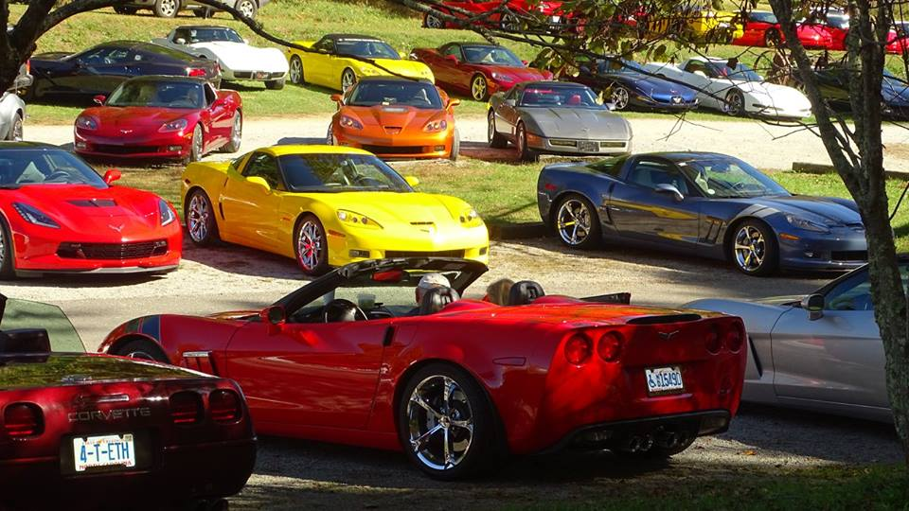**

Photo: by Blue Munday

**4th Sat. each month through Oct. Elkin Cruise-In 4PM- 9PM on Main St.**

**July 14th Movie in the Park Dobson (Jungle Book) bring lawn chairs or blankets begin at dark**

**July 15th Victory Lane Corvette Club - Make a Wish Foundation**

**July 21-22 Smoke on the Mountain BBQ Galax VA**

**July 28th & Aug. 25th Cruisin’ & Grooving Galax**

**July 22nd 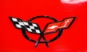 Founder’s Day Ride - Olde Beau Luncheon Cake & homemade Ice Cream at the Mecimore’s**

**July 22nd Scotty’s in Taylorsville Apple City Street Rodders**

**July 29th Charlotte Motor Speedway $25 - 3 laps in your car**

**July 28th & 29th Cruisin’ the Heartland KY**

**July 29th Cars & Coffee Concord**

**Aug. 5th Plastic Cars Ltd Car Show Exit 50 off I-77 Single Hill Mall**

**Aug. 12 Ride with Tony, Mike & Kyle meet at Earnhardt Chevrolet**

**Aug. 19th Beach Music & Vettes North Wilkesboro**

**Sept. 23rd Car Show Purlear Baptist Church (Tom Mc Neil)**

**Sept. 30th 10th Annual Foothills Corvette Club - All GM Cruise-In at Empire Chevrolet**

**Sept. 30 Bowling Green Assembly Plant Corvette Club Charity Show**

**Oct. 22nd**  **Run to the Colors**

**Nov. 11th Hot Rods & Moonshine North Wilkesboro**

**Dec. 16th  Christmas Dinner - Olde Beau**

**2008 Indy Pace Car 3LT 6 Speed Manual Corvette**

**(See Vince Catalano)**

### C:\Users\Susie\AppData\Local\Temp\20170325_162116.jpg C:\Users\Susie\AppData\Local\Temp\20170325_162100.jpg

### ALSO,

### 2006 3LT Convertible 32,000 Joe Rankin 336-957-0668

Mark your calendars for the 25th anniversary of the National Corvette Museum. The 2019 Corvette Caravan from all over the country will be headed to Bowling Green KY. We had a great time in 2014 and I’m sure 2019 will be an unforgettable event.

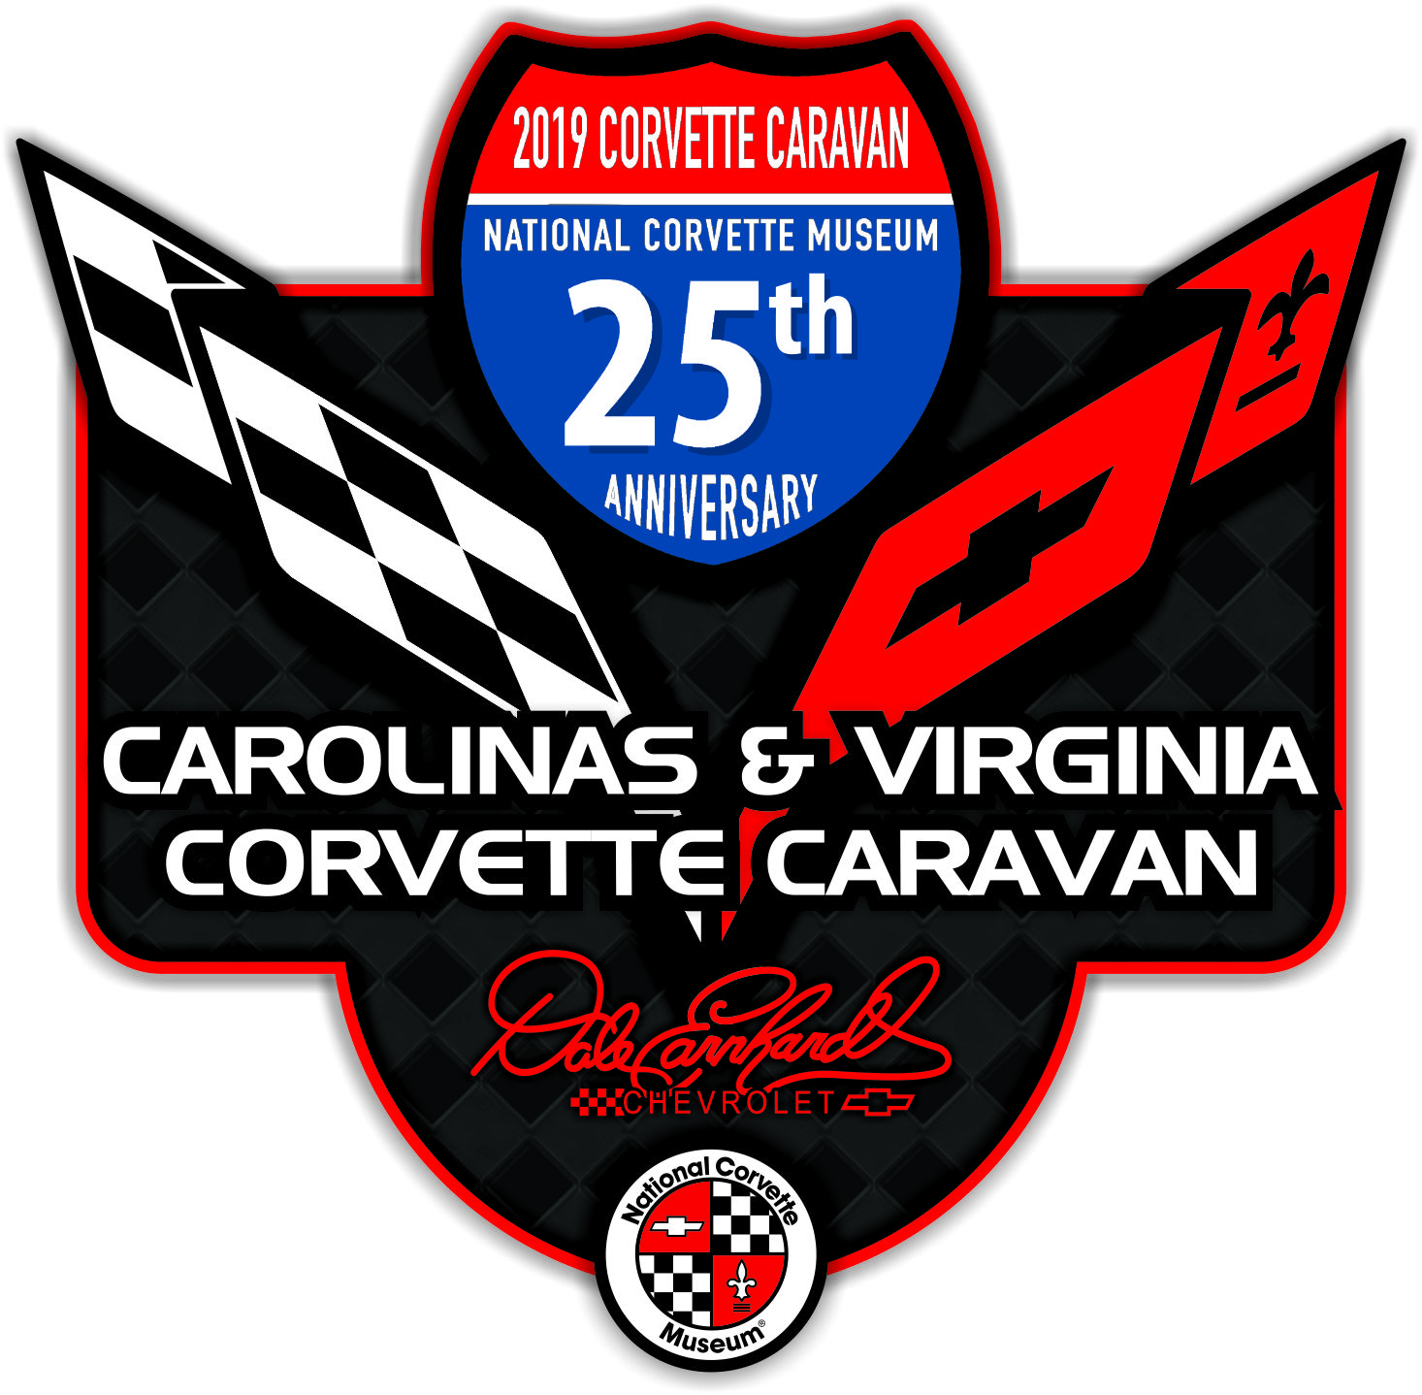

**Holyfield Buttermilk Chocolate Cake**

**2 Cups Sugar**

**2 Cups Plain Flour**

**1 Cup Water**

**1 Cup Vegetable Oil**

**1 Stick Butter**

**4 Tablespoons Cocoa**

**½ Cup Buttermilk**

**2 Eggs**

**1 Teaspoon Baking Soda**

**1 Teaspoon Vanilla**

**Dash Salt**

**Mix flour and sugar well in a large bowl and set aside.**

**In a sauce pan, combine water, oil, butter, and cocoa. Bring to a boil and boil for one minute stirring constantly.**

**Pour this mixture over the flour and sugar. Add buttermilk, eggs, soda, salt and vanilla. Mix well and pour into a 13 X 9 well greased and floured pan.**

**Bake 325 until done.**

**ICING:**

**4 Tablespoons Milk**

**4 Tablespoons Cocoa**

**1 Box Confectioner Sugar**

**1 Stick Butter**

**1 Teaspoon Vanilla**

**Bring milk, butter, cocoa and vanilla to a boil. Boil for one minute. Remove from heat and stir in confectioner sugar. Pour over cake while it is still warm.**