  **January 2025 Newsletter**

[www.foothillscorvetteclub.net](http://www.foothillscorvetteclub.net)

**2025 Officers Board of Directors**

**President: Don Harrington Tony Guappone - Chairman**

**Vice President: Rick Jones Joan Holyfield, David Mecimore,**

**Secretary: Rose Taylor David Greer, Michael Carrigan**

**Treasurer: Priscilla Norris**

**Membership Manager: Twyla Price Historian – Don Harrington**

**Directory Manager: Twyla Price Communication: Wanda Harrington**

**VA Rep: Dick Cooley Web Master – Lee Allen**

**Chaplain: Mark Brittan, David Mecimore**

**Photographers – Derry Hendrix, Cassie Shaw, Lee Allen, Darlene Mecimore**

**Newsletter Editor: Lee Allen**

**Facebook/Club Shirts: Derry Hendrix**

**Care and Condolences: Halene Miller**

**\*Virginia FCC Members, Representative Dick Cooley, will meet every 3rd Tuesday of each month in Galax, VA. Location TBA**

**Foothills Corvette Club Sponsors for 2025**

* **McNeil Chevrolet of Wilkesboro**



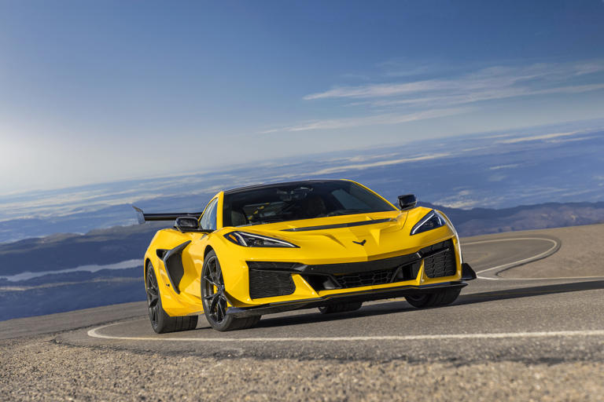

**The 2025 Corvette ZR1 will be ready for orders in late February 2025. With a top speed of 233mph powered by a twin-turbo, flat-pane crank V8 producing an astounding 1054hp. With a starting price of $174,995 this beast is sure to be a force to be reckoned with.**

**March 31st is the deadline to pay your club dues if you have not done so including a 10.00 late fee. Please do so ASAP!**



**January Birthdays**

|  |  |  |
| --- | --- | --- |
| Alan | Stafford | 3 |
| Karen | Brittain | 3 |
| David | Shelton | 11 |
| Sheila | Guappone | 11 |
| Teresa | Gibson | 14 |
| Jimmy | McKnight | 16 |
| Conway | Powell | 18 |
| Michael | Carrigan | 18 |
| Lethy | Yates | 27 |

****January Anniversaries**

Alan and Amanda Stafford 7

Pat and Brenda Harner 28

***RIDES/EVENT***

**January**

**Game Night- TBD**

**February**

**Ride-**

**March**

**13-15 Corvette Expo @ The Leconte Center in Pigeon Forge, Tennessee.**

**April**

**Ride-**

**May**

**Ride- Matt and Cassie**

**24- Shelton Vineyards Corvette Show. Dobson, NC**

**June**

**Ride-**

**7- Corvettes at the Beach Car Show in Myrtle Beach, SC.**

**July**

**Ride-**

**August**

**Ride-**

**21-23 Corvettes at Carlisle**

**September**

**Ride-**

**October**

**Ride-**

**Annual Run to the Colors TBA**

**November**

**Ride-**

**December**

**FCC Annual Christmas Party**

***Prayers***

*Jimmie Holyfield*

*Larry and Twyla Price*

*Conway Powell*

*Dick Cooley*

*Halene Miller*

*Rick Jones*

*Michael and Delores Carrigan*

*Donnie Harrington*

***Please keep all these above dedicated members in your prayers, and some that may not be mentioned. Please let me or Wanda know if I need to add more or take some off.***



If you have a corvette or corvette parts for sale, please send an email with information and pictures to Lee Allen [gizmo-24@hotmail.com](mailto:gizmo-24@hotmail.com) (information will be advertised in the monthly newsletter)

***I joined for the cars, stayed because of the people”*** *Kendall Hendrix*